Jonathan Goohs

1 Oct 2025

CS3022 Lab 0 Report

1. ADA

How are variables assigned in Ada?

The := operator (syntax of type name := value;

How are arrays declared?

Type array_name is array(values) of typeofarrayelements

Where are they declared? Is this good or bad? Why?

In the procedure section of the code. This seems good for the interpreter to parse things since every statement type (assignment/declaration up top and then operations on below in the begin section). However, this would seem hard to program in from a flow control standpoint because if I had a large codebase I would have to keep scrolling to the top to initialize a new var and then bring that context down to its respective operation.

1. Fortran
   1. Why are goto statements awesome? Why are they not?
      1. Goto statements allow clear jump points to specified sections of code on a conditional or unconditional basis which allows clear instructions of how to progress through the written code. With a large number of goto statements, the ability to follow the flow becomes increasingly cumbersome.
   2. Discuss the benefit of restrictions on the programmer?
      1. The benefits of Fortran restrictions like comment formatting and variable capitalization creates increased readability of the code written, enhancing the ability to create good will in the language for enhanced user adoption.

1. Algol 68

* + In ALGOL (especially ALGOL 68), semicolons are used as **statement separators**, not as terminators. This means semicolons separate adjacent statements within a sequence, but there is no semicolon after the last statement in the sequence. Discuss the benefits of this approach.
    - It can be used to enhance readability of the code. If there is no semicolon at the end of a block of code, you know the sequence has ended

1. Cobol

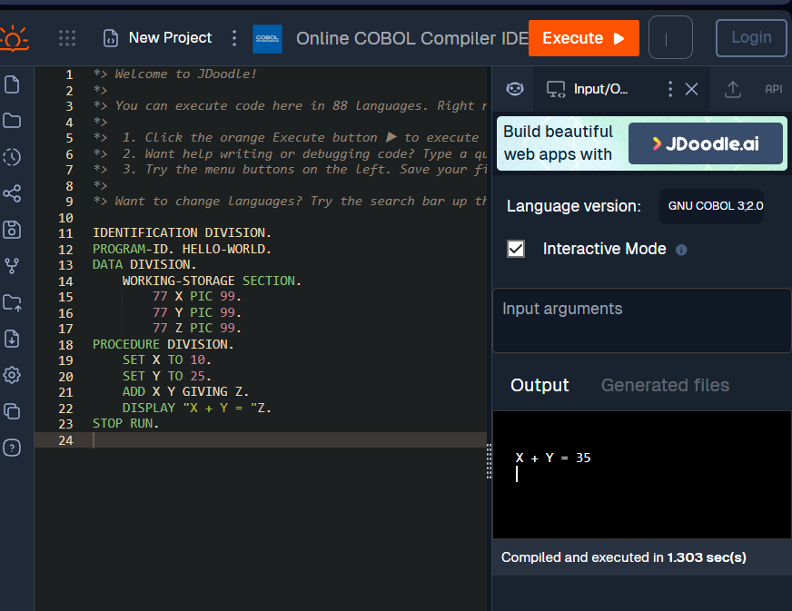

* There is a semantic error in this code. What is it?
  + This is supposed to be a hello world program and it adds integers.

How is string concatenation done? Do you like this?

* + String concatenation is done by just putting strings next to each other with a space. I don’t necessarily like this given the opportunity to not be clear in your syntax, especially when at the point of putting two strings together, you could just write it all in one string. See below:

1. Pascal

* If you could design a language, how would you do comments?
  + I would do comments with a unique symbol that isn’t used in programming languages for anything else so programmers wouldn’t accidentally use it. I think # or @ are good symbols.

1. Batch File (Windows)

> (Redirection/Overwrite): This operator redirects the output of a command to a specified file.

* If the target file does not exist, it will be created.
* If the target file does exist, its entire content will be overwritten with the new output.

>> (Append): This operator redirects the output of a command to a specified file, appending the new output to the end of the existing content.

* If the target file does not exist, it will be created.
* If the target file does exist, the new output will be appended to the end of the file, preserving the original content.

1. Go

* There are two types, ch and result. One is inferred that it will be an int, the other is explicitly declared. What are the benefits to allowing implicit typing?
  + Ease of adoption, safety, semantic specificity. Strict typing creates a barrier for new programmers as they must be more careful about how they assign variables. The math on an unsigned int versus and int is quite different and if you are dealing with large numbers, you as a programmer have to know which type is necessary for your use case.
* Is the function worker ever executed in the main thread?
  + Yes, as ch<-42 assignment is the result of the worker function running.

1. VBA

* Why have statement terminators like semi-colons?
  + Explicit statement terminators help readability of code and allow the compiler to know how to parse each statement to do operations and assignment of variables with lack of ambiguity.

1. Prolog

* What would happen to the execution if you place the Rule’s section above the Facts section?
  + Nothing changes in the output.

1. Haskell

* + Explain the function header:

evenOrOdd :: Integer -> String

What is meant by evenOrOdd,

Integer, and String?

* + The function takes in an integer and outputs a string, called by the name evenOrOdd.